VAST spatial delta-GLMM Evaluation

# Background

Fishery-independent survey data represent one of the most important sources of information for stock assessment (Francis 2011, Methot et al. 2014). The NOAA-AFSC Groundfish Assessment Program conducts biennial bottom trawl surveys in the Gulf of Alaska and Aleutian Islands regions using a stratified random sample design, with effort allocated among strata based on observed catch rates, stratum variances, and stratum areas (von Szalay and Raring 2016). While design-based methods provide unbiased estimates of biomass for stratified random sample designs, a positive skew, wide tails, or a large number of zero observations (tows) can lead to unbiased but imprecise estimates of biomass (Thorson et al. 2011, Shelton et al. 2014). This is particularly problematic for patchily-distributed species whose non-uniform distributions in space result in large proportions of zero observations. Furthermore, design-based estimators assume uniform density within strata, ignoring information provided by the spatial correlation structure across sample locations.

Two alternative approaches to index standardization present potential opportunities to reduce uncertainty in biomass indices from GOA and AI bottom trawl survey data, and which may be more robust to reductions in sampling effort. The first is to model biomass observations as the joint probability of encounter probability and positive catch rates. Known within the fisheries literature as delta generalized linear mixed models (Stefansson 1996, Maunder and Punt 2004) and more generally as hurdle models (Ver Hoef and Jansen 2007), methods that model these two components of catch rate observations have been found to better partition variance and reduce uncertainty in survey indices. Delta generalized mixed models have found increased use for standardization of zero-inflated survey data in recent years, especially for US West Coast groundfish (Thorson and Ward 2014, Thorson et al. 2015a).

The second are geostatistical methods for modeling the correlation structure in biomass observations across space. Design-based estimators of biomass calculate average density within sampling strata, based on observed catches given area swept, and assume average biomass of a species within the pre-specified sampling stratum. As a result, variance among samples within a stratum result in an increase in the variance estimated for species biomass. However, Shelton et al. (2014) illustrated that for darkblotched rockfish (*Sebastes cramerai*) much of the variation in survey catches could be explained by spatially-correlated variability in habitat quality, and that accounting for the location of samples resulted in significant reductions in uncertainty for biomass indices derived from trawl survey data. In addition to increased precision of abundance indices for darkblotched rockfish, geostatistical model estimates did not have the spikes in abundance which had been deemed implausible for such a long-lived species (Gertseva and Thorson 2013).

Thorson et al. (2015a) developed a generalized maximum likelihood estimator for geostatistical index standardization, which approximate spatial and spatiotemporal variation in catch rates as Gaussian Markov random fields (Thorson et al. 2015b). When this geostatistical delta-glmm was applied to 28 groundfish species encountered in the U.S. West Coast trawl survey, estimation intervals from the conventional design-based approach were 60% larger on average than those derived from the geostatistical model-based estimator, but the trend and scale of resulting indices were generally consistent between methods (Thorson et al. 2015a). When applied to simulated data, Thorson et al. (2015a) found the geostatistical delta-glmm provided unbiased estimates of abundance, with well-calibrated confidence intervals that indicated greater precision than design-based estimators. Overall, the current body of research suggests that by modeling both encounter probability and positive catch rate probabilities together, and estimating spatial and spatiotemporal correlation, geostatistical delta-glmm’s are able to explain more of the variability in catch rate data, produce indices of abundance with greater precision than conventional design-based estimators, and may be able to use trawl survey data more efficiently.

# Purpose

A general platform for implementation of geostatistical delta-glmm for survey data is now available through the VAST (vector-autoregressive spatio-temporal) model package (Thorson and Barnett 2017), which is utilizes Template Model Builder (Kristensen et al. 2014) for estimation of fixed and random effects. Given the survey design for the NMFS Gulf of Alaska and Aleutian Islands bottom trawl surveys, there is interest in exploring this geostatistical delta-glmm for model-based index standardization. However, prior to adopting these new methods it is necessary to compare current design-based indices with VAST model-based indices for a range of species (Table 1) with different life histories and spatial distributions, and evaluate sensitivity of model results to a range of specification options.

Table 1 Survey data included in the analysis of the geostatistical delta-glmm. Survey data for each species and region combination were evaluated separately.

|  |  |  |
| --- | --- | --- |
| **Common Name** | **Scientific Name** | **Region** |
| Arrowtooth flounder | *Atheresthes stomias* | Gulf of Alaska |
| Big skate | *Beringraja binoculata* | Gulf of Alaska |
| Dover sole | *Microstomus pacificus* | Gulf of Alaska |
| Harlequin rockfish | *Sebastes variegatus* | Gulf of Alaska |
| Northern rockfish | *Sebastes polyspinis* | Gulf of Alaska |
| Pacific cod | *Gadus macrocephalus* | Gulf of Alaska |
| Pacific ocean perch | *Sebastes alutus* | Gulf of Alaska |
| Spiny dogfish | *Squalus suckleyi* | Gulf of Alaska |
| Walleye pollock | *Gadus chalcogrammus* | Gulf of Alaska |
| Atka mackerel | *Pleurogrammus monopterygius* | Aleutian Islands |
| Northern rockfish | *Sebastes polyspinis* | Aleutian Islands |
| Pacific cod | *Gadus macrocephalus* | Aleutian Islands |
| Pacific ocean perch | *Sebastes alutus* | Aleutian Islands |
| Walleye pollock | *Gadus chalcogrammus* | Aleutian Islands |

VAST geostatistical delta-glmm’s were fit to NMFS/AFSC bottom trawl survey data for a range of species and regions (Table 1), in order to address the following questions:

1. How do VAST indices of abundance compare with design-based estimates?
2. What are the differences in estimation intervals produced by VAST (model-based) and design-based estimators?
3. How does the level of spatial complexity (number of knots specified) influence the trend, scale, and uncertainty in resulting indices of abundance?
4. How does specification of autocorrelation in the intercept for encounter probability and positive catch rate components influence indices of abundance?
5. How do estimates for apportionment across Gulf of Alaska regions compare between random effects and VAST models?

# Model Specifications

Across all test cases some baseline model specifications were implemented:

1. Both spatial and spatio-temporal covariation was allowed (i.e. FieldConfig).
2. No random covariation in catchability was assumed (i.e. OverdispersionConfig).
3. The observation model followed the standard delta model format with a logit link for encounter probability, lognormal distribution for positive catch rates (i.e. ObsModel).
4. The bias correction option in VAST was turned OFF.

# Knot Number Sensitivity and Comparison with Design-based Estimates

To compare the trend, scale, and uncertainty of design-based indices with those from the geostatistical delta-glmm alternative, single-species VAST models were fit to available survey data with varying numbers of knots.

The knot number in a VAST model specifies the level of spatial complexity (Fig. 1). For a given number of knots specified by the user (n_x), the k-means algorithm identifies the optimal location of these knots that minimizes the total distance between available data (tows) and the location of the nearest knot (Thorson et al. 2015a).

To evaluate the sensitivity of model-based survey index and variance estimates to the number of knots specified, separate VAST models were run for a range of species of interest in the Gulf of Alaska and Aleutian Island surveys. Annual values and uncertainty (CV) estimates for the VAST model-based and traditional design-based indices are compared below.



Figure 1 Example from of how the knot number specification influences the level of spatial complexity within a VAST model, from GOA Northern Rockfish.

## Gulf of Alaska Bottom Trawl Survey

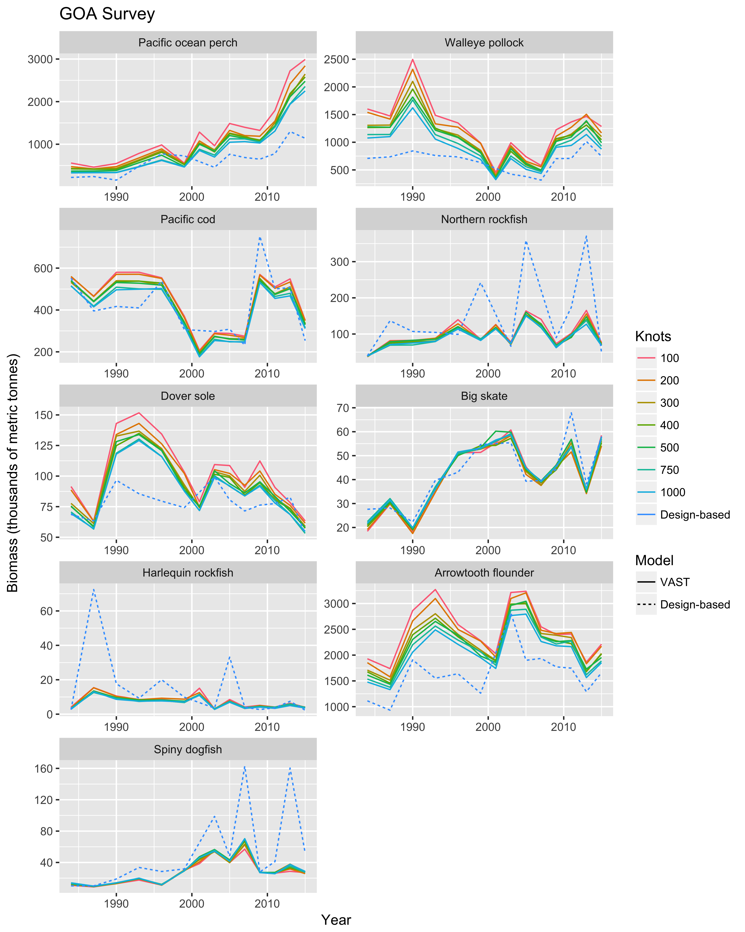

Figure 2 Comparison of annual survey index estimates across species, models, and VAST knot number specifications, for the Gulf of Alaska bottom trawl survey. Each boxplot describes the distribution of estimated CV’s across survey years.

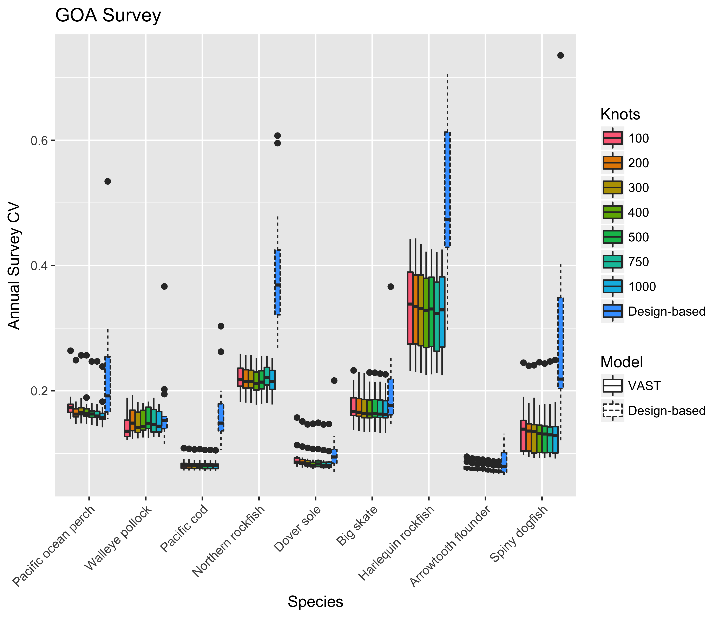

Figure 3 Comparison of annual survey uncertainty (CV) across species, model types, and VAST knot number specifications, for the Gulf of Alaska bottom trawl survey. Each boxplot describes the distribution of estimated CV’s across survey years.

## Aleutian Islands Bottom Trawl Survey

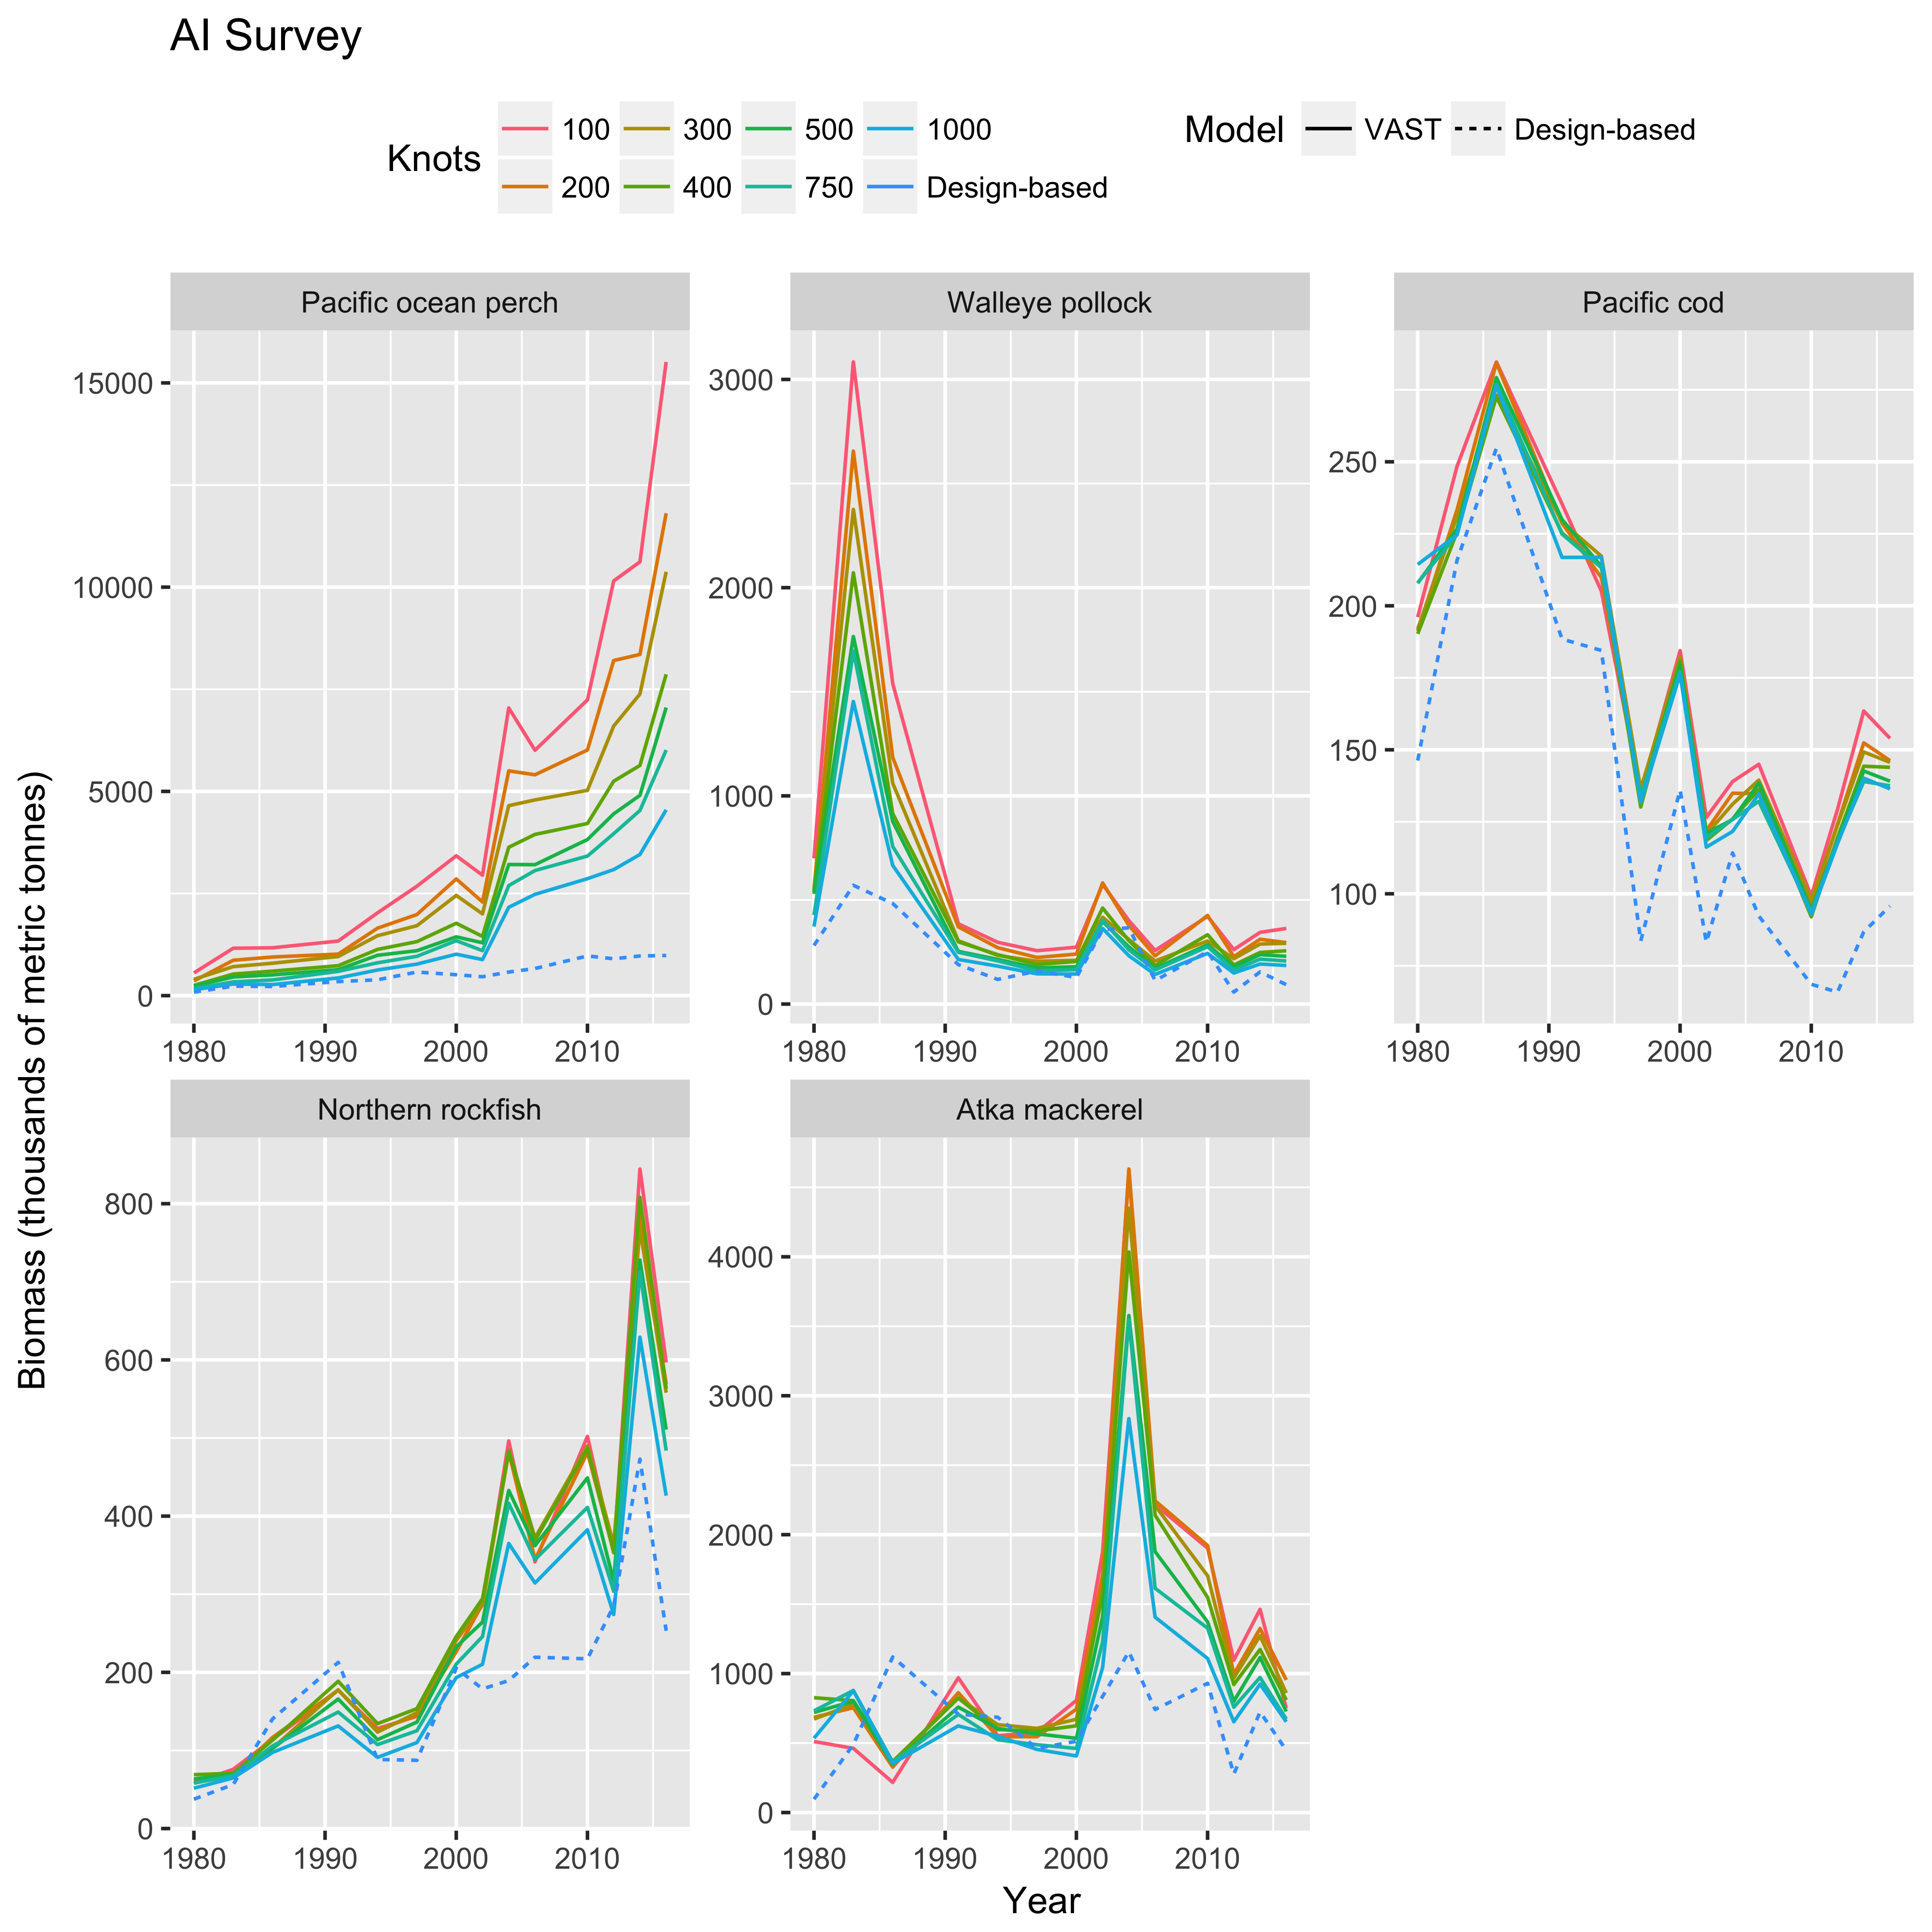

Figure 4 Comparison of annual survey index estimates across species, models, and VAST knot number specifications, for the Aleutian Islands bottom trawl survey. Each boxplot describes the distribution of estimated CV’s across survey years.

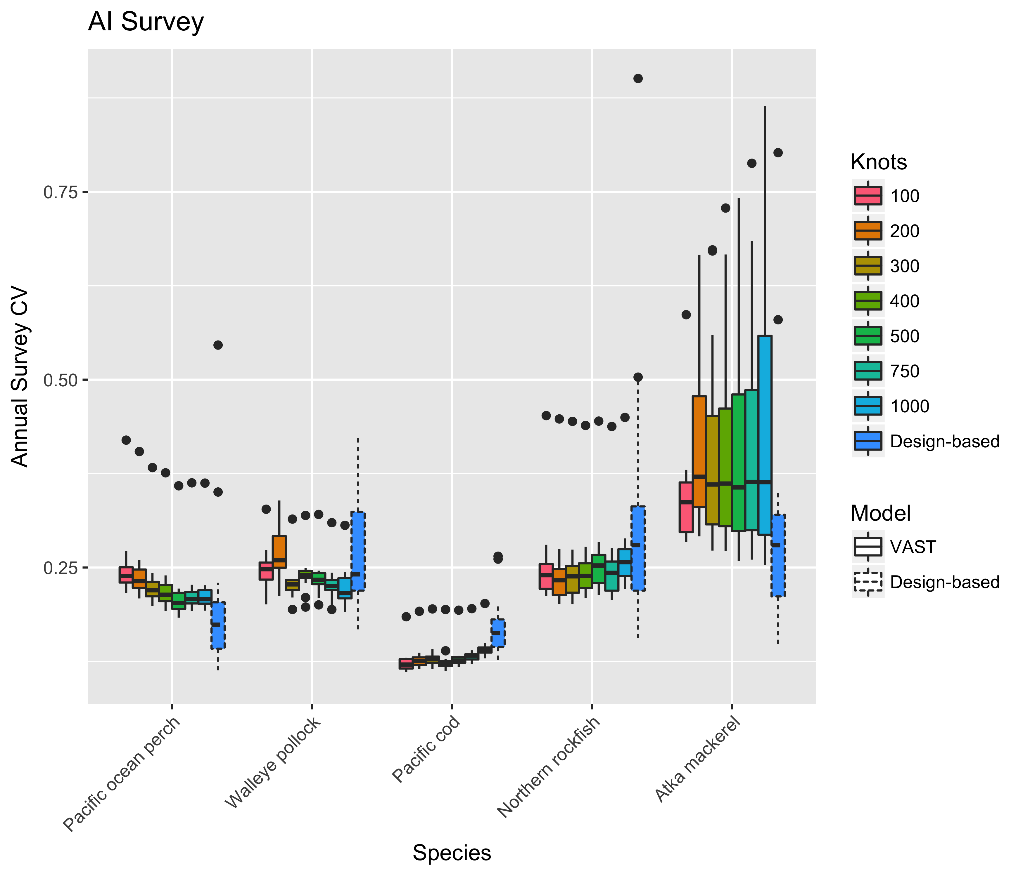

Figure 5 Comparison of annual survey uncertainty (CV) across species, model types, and VAST knot number specifications, for the Aleutian Islands bottom trawl survey. Each boxplot describes the distribution of estimated CV’s across survey years.

# Comparison of Intercept Specifications for Encounter Probability and Positive Catch Rate

# Gulf of Alaska Apportionment Comparison

One areas of interest outlined in previous discussions was the use of area-stratified VAST models for apportionment calculations. Within the Gulf of Alaska, apportionment estimates were compared between the stratified VAST model and the ADMB-RE model. Inputs for the ADMB-RE model were separate design-based indices generated for the Western, Central, and Eastern GOA, and the ADMB-RE model assumed separate process errors for each index. Results were rather insensitive to a range of knot numbers, (knots=500 shown below), and whether the intercepts for both encounter probability and positive catch rate components of the spatial delta-GLMM were specified as random-walk or lag-1 auto correlated processes over time.

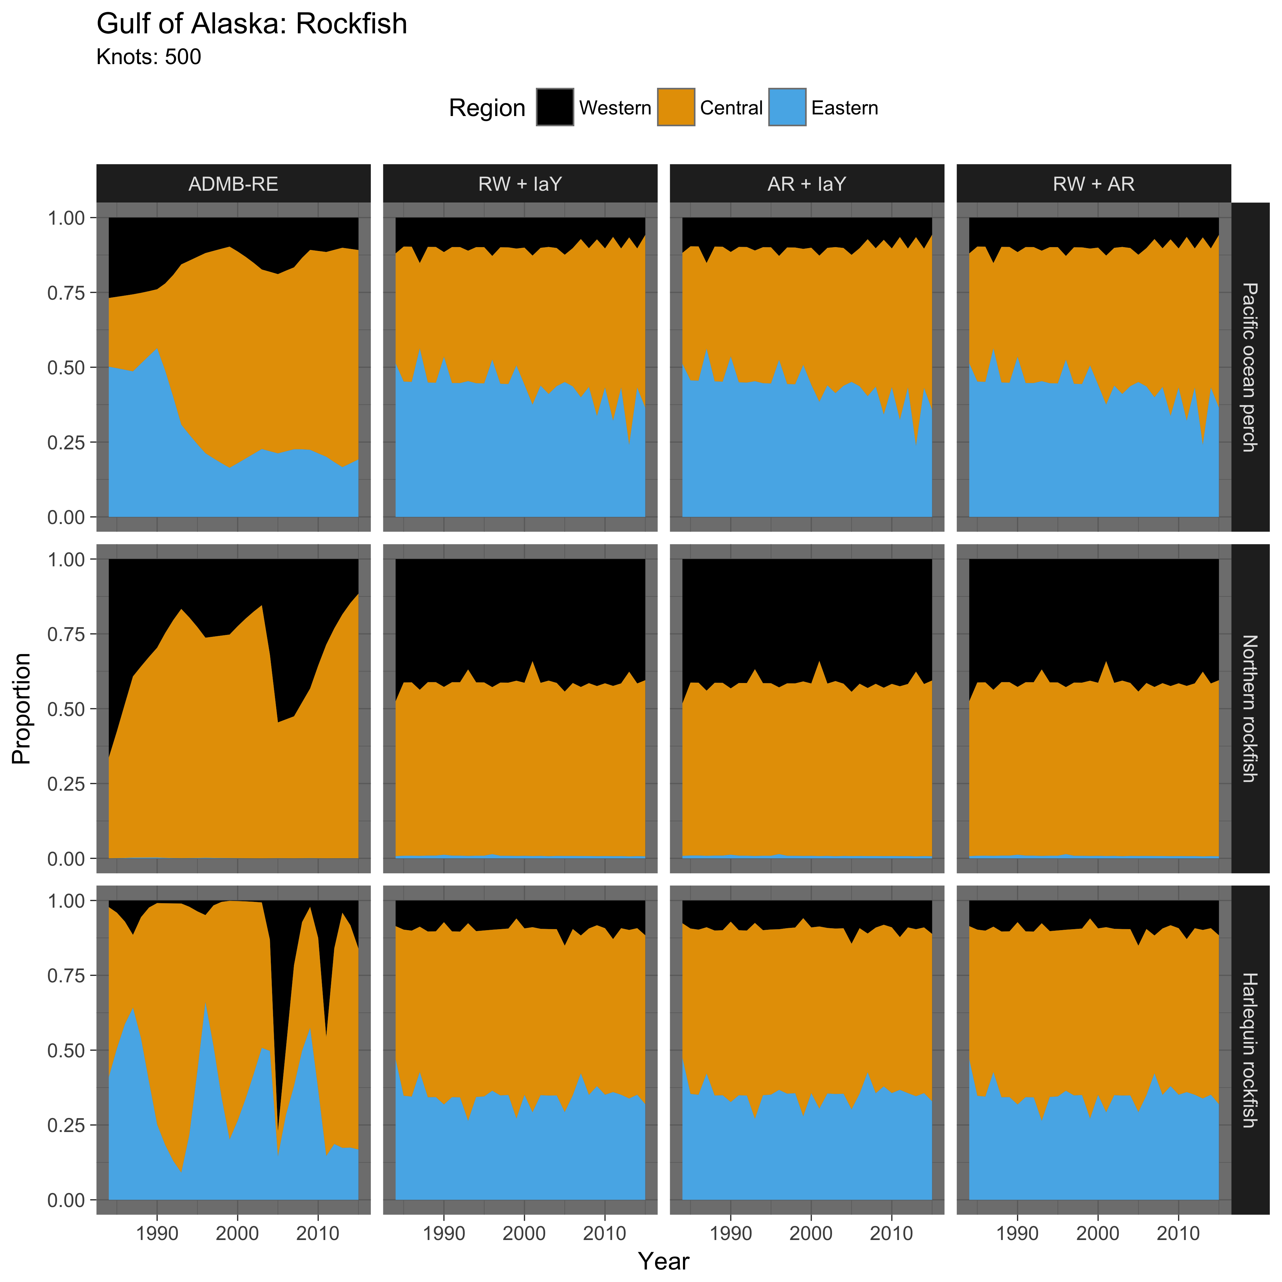

Figure 6 Comparison of apportionment predictions from the ADMB-RE and stratified VAST models, across three rockfish species in the Gulf of Alaska. VAST model configurations are listed at top of the figure, with

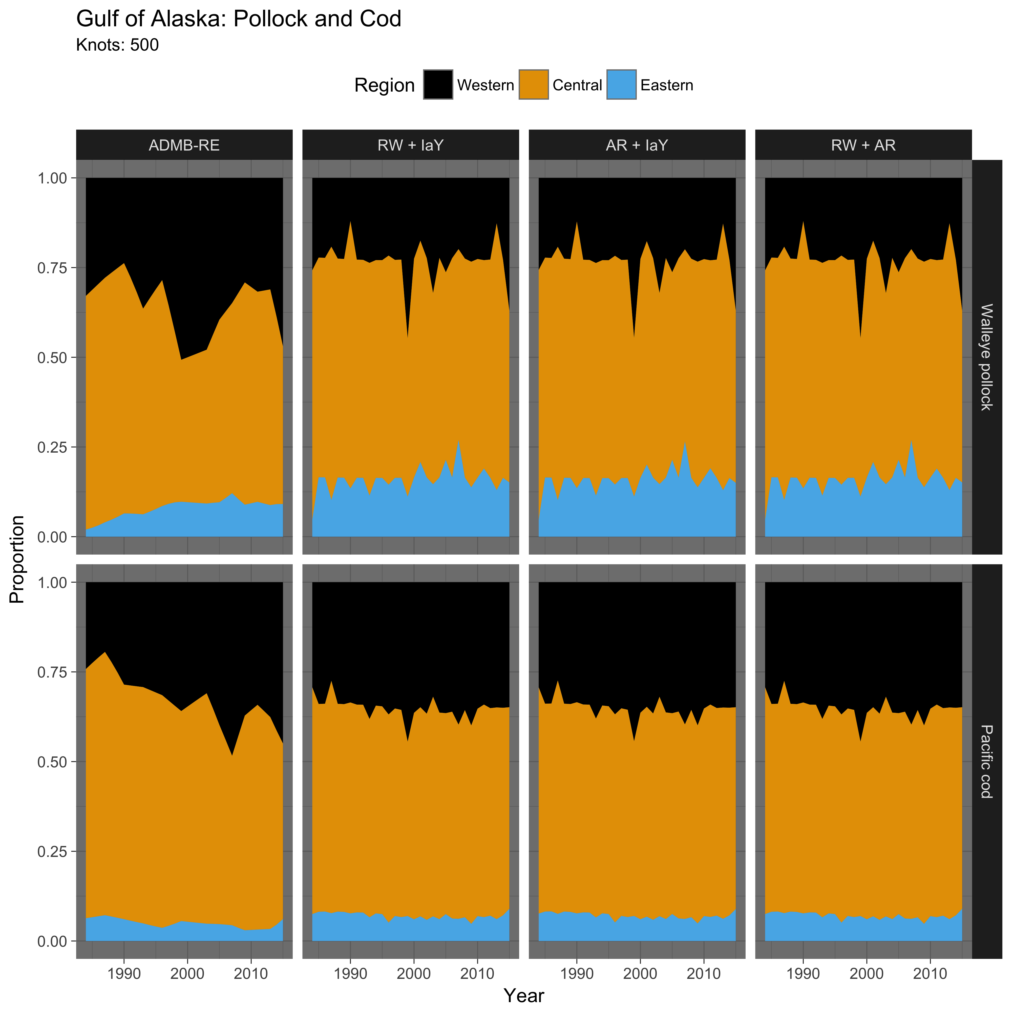

Figure 7 Comparison of apportionment predictions from the ADMB-RE and stratified VAST models, across other species in the Gulf of Alaska.

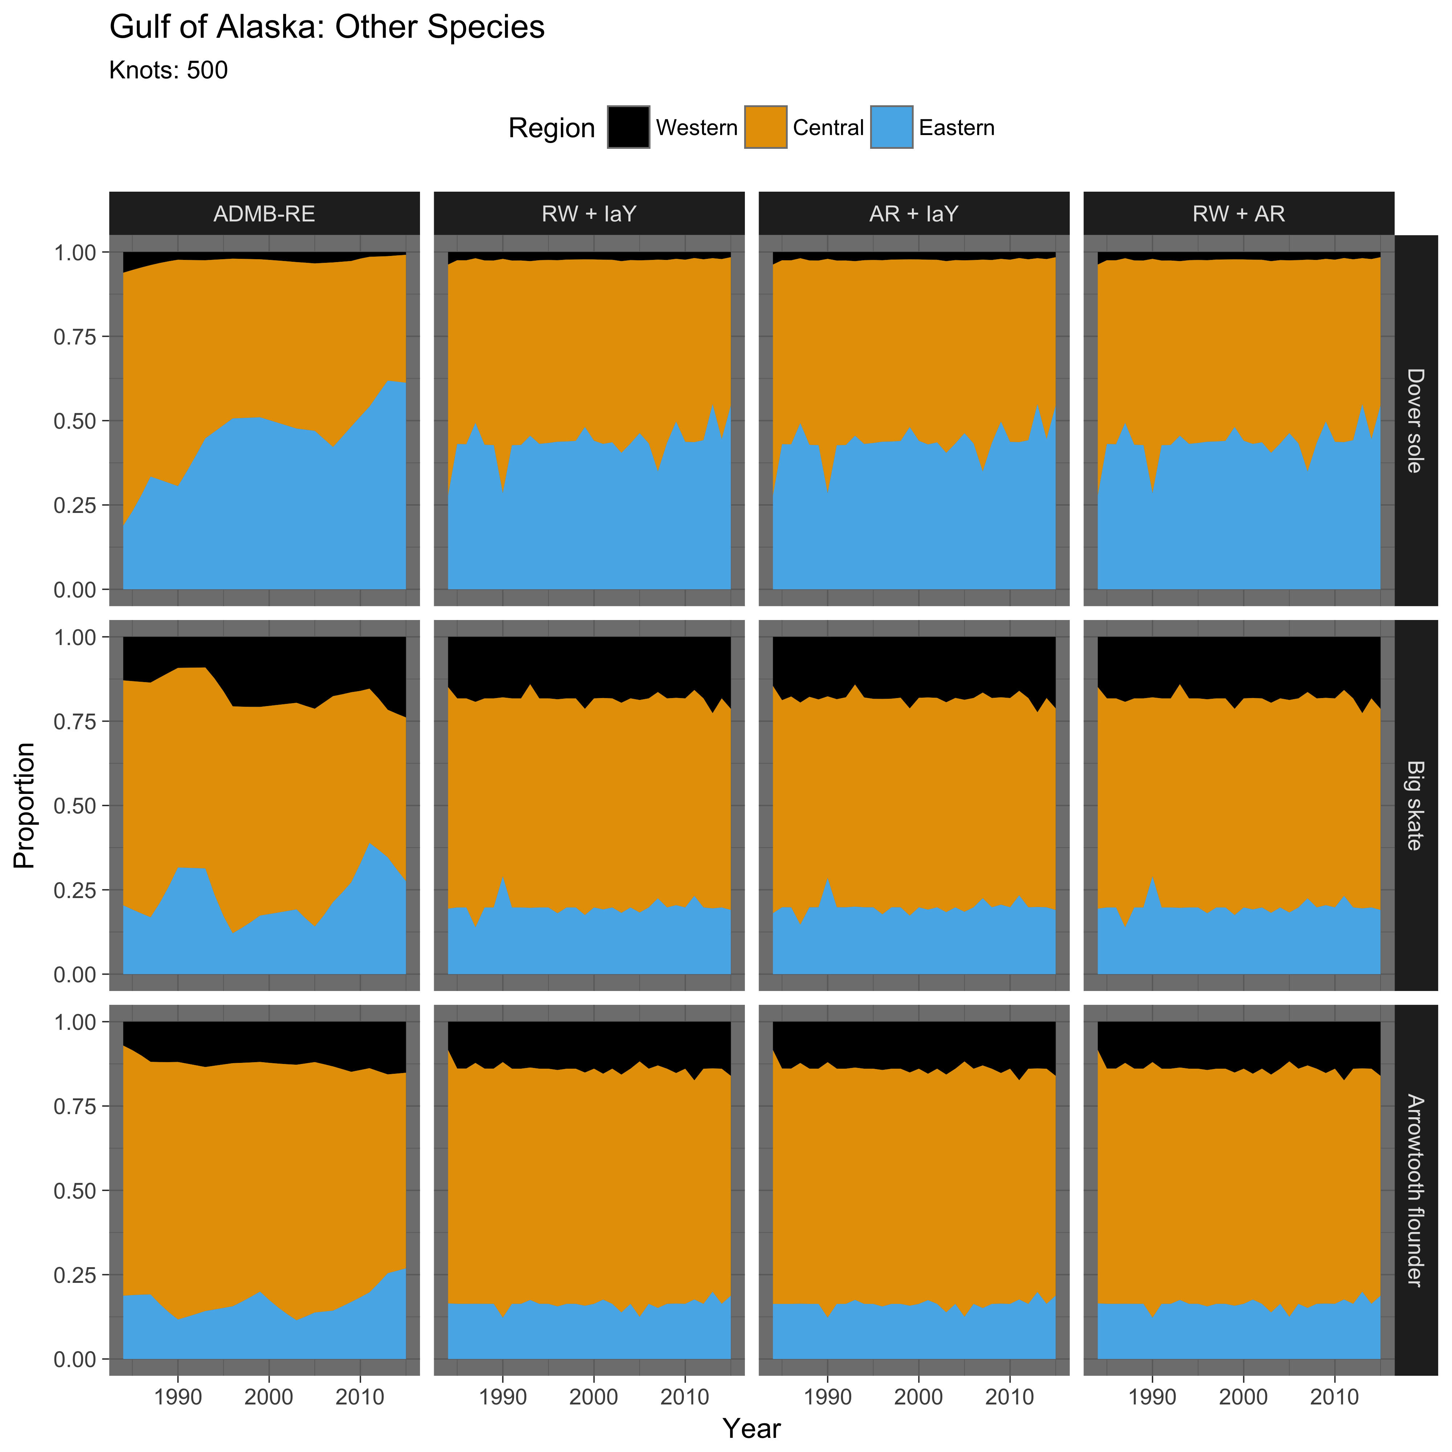

# Further Exploration

Bias correction

Inclusion of depth observation from each trawl as a covariate for PCR and EC

(Thorson and Kristensen 2016)

# References

Francis, R. I. C. C. 2011. Data weighting in statistical fisheries stock assessment models. Canadian Journal of Fisheries and Aquatic Sciences **68**:1124-1138.

Gertseva, V., and J. T. Thorson. 2013. Status of the darkblotched rockfish resource off the continental U.S. Pacific Coast in 2013. National Marine Fisheries Service, Northwest Fisheries Science Center, Fisheries Resource and Monitoring Division, Seattle, WA.

Kristensen, K., U. H. Thygesen, K. H. Andersen, J. E. Beyer, and J. M. Jech. 2014. Estimating spatio-temporal dynamics of size-structured populations. Canadian Journal of Fisheries and Aquatic Sciences **71**:326-336.

Maunder, M. N., and A. E. Punt. 2004. Standardizing catch and effort data: a review of recent approaches. Fisheries Research **70**:141-159.

Methot, R. D., G. R. Tromble, D. M. Lambert, and K. E. Greene. 2014. Implementing a science-based system for preventing overfishing and guiding sustainable fisheries in the United States. ICES Journal of Marine Science **71**:183-194.

Shelton, A. O., J. T. Thorson, E. J. Ward, and B. E. Feist. 2014. Spatial semiparametric models improve estimates of species abundance and distribution. Canadian Journal of Fisheries and Aquatic Sciences **71**:1655-1666.

Stefansson, G. 1996. Analysis of groundfish survey abundance data: combining the GLM and delta approaches. ICES Journal of Marine Science **53**:577-588.

Thorson, J. T., and L. A. K. Barnett. 2017. Comparing estimates of abundance trends and distribution shifts using single- and multispecies models of fishes and biogenic habitat. ICES Journal of Marine Science **75**:1311-1321.

Thorson, J. T., and K. Kristensen. 2016. Implementing a generic method for bias correction in statistical models using random effects, with spatial and population dynamics examples. Fisheries Research **175**:66-74.

Thorson, J. T., A. O. Shelton, E. J. Ward, and H. J. Skaug. 2015a. Geostatistical delta-generalized linear mixed models improve precision for estimated abundance indices for West Coast groundfishes. ICES Journal of Marine Science **72**:1297-1310.

Thorson, J. T., H. J. Skaug, K. Kristensen, A. O. Shelton, E. J. Ward, J. H. Harms, and J. A. Benante. 2015b. The importance of spatial models for estimating the strength of density dependence. Ecology **96**:1202-1212.

Thorson, J. T., I. J. Stewart, and A. E. Punt. 2011. Accounting for fish shoals in single- and multi-species survey data using mixture distribution models. Canadian Journal of Fisheries and Aquatic Sciences **68**:1681-1693.

Thorson, J. T., and E. J. Ward. 2014. Accounting for vessel effects when standardizing catch rates among cooperative surveys. Fisheries Research **155**:168-176.

Ver Hoef, J. M., and J. K. Jansen. 2007. Space—time zero-inflated count models of Harbor seals. Environmetrics **18**:697-712.

von Szalay, P. G., and N. W. Raring. 2016. Data report: 2015 Gulf of Alaska bottom trawl survey., U.S. Dep. of Commer.